Alps Road Elementary
School Counselor
Constructing a Foundation for Success
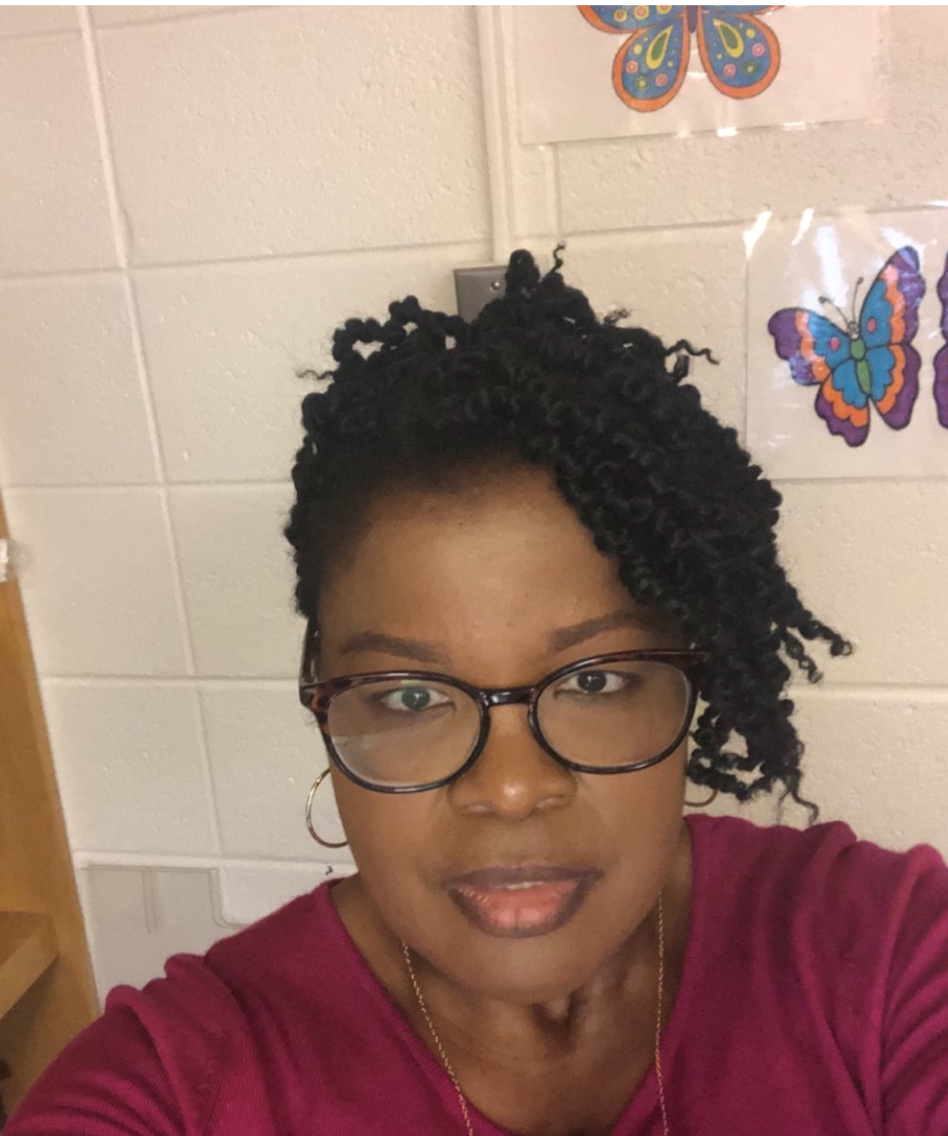
I am Karen Josephs and I am the new school counselor at Alps Road Elementary. I am excited to be a part of the Alps Road Elementary family. I have heard some great things about the school and the community and I feel extremely lucky to be a part of this community. I look forward to working with you and your child this year. I will make every effort to see that your child receives as much personal assistance as possible.

My School Counseling Philosophy
I believe:
  - All students have the right to a safe, welcoming and respectful learning environment.
  - All students’ ethnic, cultural, racial, sexual, and ability differences should be valued and considered in planning, implementing, and evaluating a comprehensive school counseling program.
  - School counseling services must be student centered, data-driven, goal-oriented, and based on the developmental student competencies for all students.
  - Successful student learning requires the active participation, collaboration, mutual respect, and individual accountability of students, teachers, staff, parents, and community members.
  - A responsive counseling service is a significant and integral factor of the total instructional curriculum, designed to promote the growth of all students in academic, career, and personal/social development.
Please do not hesitate to contact me with any questions or concerns.
Ms. Karen Josephs
Josephsk@clarke.k12.ga.us
Tel: 706-548-2261 ext: 32511

